PROJECT NOTES

- THE CONTRACTOR SHALL NOT BEGIN ANY WORK SHOWN ON THESE PLANS UNTIL THE CITY ENGINEER’S SIGNATURE OF APPROVAL IS AFFIXED HEREON AND ALL APPLICABLE PERMITS HAVE BEEN OBTAINED.

- CONTRACTOR SHALL ASSUME SOLE AND COMPLETE RESPONSIBILITY FOR CONSTRUCTION OF THIS PROJECT, INCLUDING SAFETY OF ALL PERSONS AND PROPERTY. THIS REQUIREMENT SHALL APPLY CONTINUOUSLY AND NOT BE LIMITED TO NORMAL WORKING HOURS. THE CONTRACTOR SHALL DEFEND, INDEMNIFY AND HOLD THE CITY, OWNER AND THE ENGINEER HARMLESS FROM ANY AND ALL LIABILITY ARISING FROM THE SOLE NEGLIGENCE OF THE CITY, OWNER OR ENGINEER.

- THE CONTRACTOR IS HEREBY NOTIFIED THAT PRIOR TO COMMENCING CONSTRUCTION, HE SHALL CONTACT ALL UTILITY COMPANIES FOR VERIFICATION AT THE CONSTRUCTION SITE OF THE LOCATIONS OF ALL UNDERGROUND FACILITIES WHERE SUCH FACILITIES MAY CONFLICT WITH PLACEMENT OF IMPROVEMENTS SHOWN ON THIS PLAN. CALL "UNDERGROUND SERVICE ALERT" AT 811 (PHONE 800-227-2600) OR THROUGH THE WEBSITE AT HTTP://USANORTH811.ORG 48 HOURS IN ADVANCE PRIOR TO ANY EXCAVATION.

- THE LOCATIONS OF ALL UNDERGROUND FACILITIES SHOWN ON THIS PLAN ARE APPROXIMATE. A REASONABLE EFFORT HAS BEEN MADE TO LOCATE AND DELINEATE ALL UNDERGROUND FACILITIES; HOWEVER, THE ENGINEER ASSUMES NO LIABILITY FOR THE ACCURACY OR COMPLETENESS OF THE EXISTING FACILITIES SHOWN HEREON OR FOR THE EXISTENCE OF OTHER UNDERGROUND UTILITIES OR OBJECTS WHICH THE CONTRACTOR MAY DISCOVER, BUT ARE NOT SHOWN ON THESE PLANS. THE CONTRACTOR SHALL VERIFY THE LOCATION OF ALL EXISTING FACILITIES AND IMMEDIATELY NOTIFY THE ENGINEER IF ANY SUCH FACILITIES INTERFERE WITH THE CONSTRUCTION OF THE IMPROVEMENTS. THE CONTRACTOR SHALL STOP WORK UNTIL MITIGATIONS CAN BE MADE. ANY COSTS INCURRED RESULTING FROM CONTRACTOR’S FAILURE TO STOP AS DIRECTED SHALL BE THE RESPONSIBILITY OF THE CONTRACTOR.

- ALL MATERIALS, METHODS, AND WORKMANSHIP SHALL CONFORM TO THE SPECIFICATION OF THE AGENCIES INVOLVED AND ALL WORK IS SUBJECT THE APPROVAL OF THEIR DIRECTOR OR AUTHORIZED REPRESENTATIVE.

- THE CONTRACTOR SHALL NOTIFY THE CITY OF ROCKLIN’S PUBLIC SERVICES INSPECTORS MON.-FRI. 8:00 A.M. TO 4:00 P.M. AT (916) 625-5500 FOR A PRECONSTRUCTION MEETING 48 HOURS IN ADVANCE OF STARTING ANY CONSTRUCTION ACTIVITIES. PLACER COUNTY WATER AGENCY AND SOUTH PLACER MUNICIPAL UTILITY DISTRICT REQUIRE AT LEAST 48-HOURS PRIOR TO ANY CONSTRUCTION REQUESTS FOR INSPECTION OF PUBLIC FACILITIES. THEREFORE, NOTICE SHALL BE GIVEN 48-HOURS IN ADVANCE AND BE PERFORMED BY THE AGENCY’S DESIGNATED AGENT.

- THE CONTRACTOR SHALL OBTAIN ALL NECESSARY ENCROACHMENT PERMITS AND SHALL POSSESS APPROVED PLANS PRIOR TO BEGINNING OF CONSTRUCTION. A SET OF SIGNED AND APPROVED PLANS ARE TO BE ON THE JOB SITE AT ALL TIMES.

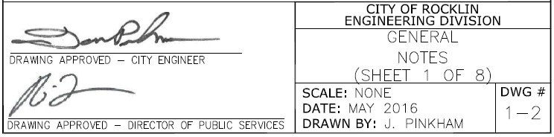

- THE CONTRACTOR SHALL MAINTAIN THE EXISTING PUBLIC AND PRIVATE IMPROVEMENT WITHIN THE WORK AREA AND SHEL ADEQUATELY BARRICADE THE PROJECT SITE TO KEEP THE GENERAL PUBLIC FROM THE SITE. ANY IMPROVEMENTS DAMAGED DURING CONSTRUCTION SHALL BE REPLACED BY CONTRACTOR.

- THE CONTRACTOR MUST EXPOSE THE END OF EXISTING GRAVITY LINES FOR THE SURVEYOR TO VERIFY LOCATION AND DEPTH OF FACILITIES PRIOR TO CONNECTION OF PROPOSED UTILITY. THE CONTRACTOR SHALL INCUR ALL COSTS FOR SUCH EXCAVATION.

- THE CONTRACTOR SHALL AT ALL TIMES COORDINATE HIS WORK WITH THAT OF OTHERS ON THE SITE. THE CONTRACTOR SHALL HAVE A RESPONSIBLE PARTY, WHO SHALL HAVE THE AUTHORITY TO REPRESENT AND ACT FOR THE CONTRACTOR ON THE JOB SITE DURING ALL WORKING HOURS.

- CONTRACTOR SHALL BE IN RECEIPT OF THE CITY APPROVED PLANS PRIOR TO CONSTRUCTION.

- CONTRACTOR SHALL NOTIFY UTILITY COMPANIES INVOLVED IN THE DEVELOPMENT PRIOR TO BEGINNING OF WORK.

- CONTRACTOR SHALL BE RESPONSIBLE FOR THE PROTECTION OF ALL EXISTING MONUMENTS AND/OR OTHER SURVEY MONUMENTS AND SHALL NOTIFY CITY OF ROCKLIN DEPARTMENT OF PUBLIC SERVICES OF ANY DAMAGED OR REMOVED CITY, STATE, OR BUREAU MONUMENTS. CONTRACTOR SHALL BE RESPONSIBLE TO RESTORE ANY DAMAGED OR REMOVED MONUMENTS.

- CONTRACTOR SHALL NOTIFY DEPARTMENT OF PUBLIC SERVICES UPON APPLICATION FOR PERMIT AND PAYMENT OF REQUIRED FEE.

- THE CONTRACTOR SHALL VERIFY ALL STREETS NAMES AND THEIR CORRECT SPELLING WITH THE FIRE DEPARTMENT AND BUILDING DIVISION BEFORE ORDERING STREET SIGNS.

- CONTRACTOR SHALL BE RESPONSIBLE FOR CONDUCTING HIS OPERATION ENTIRELY OUTSIDE OF ANY FLOODPLAIN BOUNDARIES. FLOODPLAIN BOUNDARIES SHALL BE CLEARLY DELINEATED IN THE FIELD WITH ORANGE ESA FENCING AND SIX FOOT (6’) STAKES TEN FEET (10’) OC PRIOR TO CONSTRUCTION.

- CONTRACTOR SHALL BE RESPONSIBLE FOR CONDUCTING HIS OPERATION ENTIRELY OUTSIDE OF ANY “NO GRADING AREA.” THESE AREAS SHALL BE CLEARLY DELINEATED IN THE FIELD PRIOR TO CONSTRUCTION.

- WHERE WORK IS BEING DONE IN AN OFFSITE EASEMENT THE CONTRACTOR SHALL NOTIFY THE PROPERTY OWNER 48 HOURS PRIOR TO COMMENCING WORK.

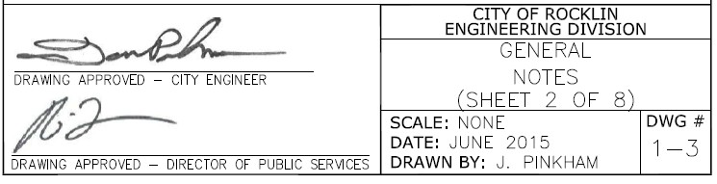

STREETS

- PLACEMENT OF PROPOSED PUBLIC IMPROVEMENTS AND PROPOSED ONSITE IMPROVEMENTS SHALL NOT BE LIMITED TO THESE PLANS, BUT BE BUILT IN ACCORDANCE WITH THE CITY OF ROCKLIN IMPROVEMENT STANDARDS AND TO THE SATISFACTION OF THE CITY ENGINEER.

- SIDEWALK RAMPS SHALL BE CONSTRUCTED AT THE CENTER OF ALL CURB RETURNS.

- ALL UTILITY TRENCHING TO BE DONE AS PER TRENCH DETAILS.

- ALL DROP INLETS SHALL BE TYPE “B” AS SHOWN IN THE CITY OF ROCKLIN IMPROVEMENT STANDARDS, DRAWING 4-2, EXCEPT AS NOTED.

- CONSTRUCT SIDEWALK RAMPS PER LATEST CALTRANS STANDARDS.

- CONSTRUCT MONUMENT BOX PER CITY OF ROCKLIN IMPROVEMENTS, STANDARD DRAWINGS 3-34.

- STOP SIGNS, THERMOPLASTIC STOP BARS, AND THE THERMOPLASTIC WORD “STOP” SHALL CONFORM TO CALTRANS STANDARDS (R1, 30”).

- THE CONTRACTOR SHALL COORDINATE WITH ALL OTHER WORK TO ASSURE THAT ALL UNDERGROUND CONDUITS AND UTILITIES ARE INSTALLED PRIOR TO PAVING. ALL PIPES IN PAVED AREAS SHELL BE PLACED PRIOR TO PLACING AGGREGATE BASE. NO CURB, GUTTER, SIDEWALK FOR AGGREGATE BASE SHALL BE PLACED UNTIL ALL UNDERGROUND UTILITIES ARE INSTALLED.

- EXISTING A.C. SURFACE SHALL BE CUT TO A NEAT STRAIGHT LINE, PARALLEL WITH THE STREET CENTERLINE AND THE EXPOSED EDGE AND VERTICAL EDGE OF GUTTER LIP SHALL BE TACKED WITH EMULSION PRIOR TO PAVING. THE CONTRACTOR SHALL PREVENT SAW CUT MATERIAL FROM ENTERING DRAINAGE STRUCTURES, WATERWAYS, DRAINAGE SWALES, ETC.

MATERIAL SHALL BE GRADED, RECOMPACTED, AND RESEALED PRIOR TO PAVING. ANY CONCRETE, A.C., TREES, FENCES, AND/OR OTHER OBSTRUCTIONS REQUIRED TO CONSTRUCT THE IMPROVEMENT SHALL BE REMOVED PRIOR TO PAVING.
- TRAFFIC CONTROL PROCEDURES SHALL CONFORM TO THE MOST RECENT EDITION OF THE CALIFORNIA MANUAL ON UNIFORM TRAFFIC CONTROL DEVICES (CA MUTCD). THE CONTRACTOR SHALL OBTAIN APPROVAL FROM THE CITY OF ROCKLIN FOR THE METHOD OF TRAFFIC CONTROL PRIOR TO STARTING CONSTRUCTION.

- THE CONTRACTOR WILL BE RESPONSIBLE FOR ANY DAMAGE TO THE STREETS OR SIDEWALKS DURING THE CONSTRUCTION PHASE. IF THE CITY FINDS A SIGNIFICANT AMOUNT OF STREET DAMAGE, AN OVERLAY OF THE ENTIRE PROJECT OR STREET IN QUESTION WILL BE REQUIRED BEFORE A NOTICE OF COMPLETION IS PROCESSED. THE CONTRACTOR, DEVELOPER AND/OR BUILDER ARE TOTALLY RESPONSIBLE FOR THE QUALITY OF WORKMANSHIP ON THE PROJECT.

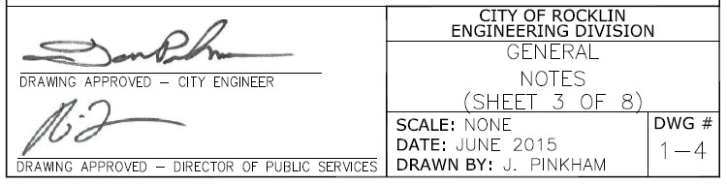

- UTILITIES:

- SEWER: | SO. PLACER MUNICIPAL UTILITY DISTRICT | (916) 786-8522
- WATER: | PLACER COUNTY WATER AGENCY | (530) 823-4886
- STORM DRAIN, TELECOMMUNICATION CONDUIT STREET LIGHTS & TRAFFIC SIGNALS:
 | CITY OF ROCKLIN (PUBLIC WORKS) | (916) 625-5500
- ELECTRICITY & NATURAL GAS: | PACIFIC GAS & ELECTRIC | (530) 320-0149
- TELEPHONE: | ATT | (916) 409-1384
- CABLE T.V.: | WAVE BROADBAND | (916) 630-7180
- CONSOLIDATED |  | (916) 786-1217

- SEE INDIVIDUAL AGENCIES FOR SIZE, TYPE, AND LOCATION OF THEIR PROPOSED FACILITIES.

- ALL OF THE ABOVE UTILITIES ARE MEMBERS OF THE “UNDERGROUND SERVICES ALERT” U.S.A.) ONE- CALL PROGRAM. THE CONTRACTOR OR ANY SUBCONTRACTOR FOR THIS PROJECT WILL BE REQUIRED TO NOTIFY MEMBERS OF (U.S.A.) 48 HOURS IN ADVANCE OF PERFORMING EXCAVATION WORK BY CALLING 811 (PHONE 800-227-2600) OR THROUGH THE WEBSITE AT HTTP://USANORTH811.ORG. EXCAVATION, FOR THE PURPOSE OF THIS REQUIREMENT, IS DEFINED AS BEING 4”—6” OR MORE IN DEPTH BELOW THE EXISTING SURFACE.

EARTHWORK AND GRADING

- THE CONTRACTOR SHALL CONTACT THE CITY OF ROCKLIN PUBLIC SERVICES, 48 HOURS PRIOR TO THE START OF EARTHWORK AND GRADING CONSTRUCTION.

- GRADING SHALL NOT OCCUR ON THE PROJECT AREA UNTIL ALL EXISTING UTILITIES AND TREES AND SENSITIVE AREAS TO BE SAVED ARE ADEQUATELY PROTECTED PER THE CITY OF ROCKLIN CONSTRUCTION SPECIFICATIONS.

- ALL COMPACTION TESTING SHALL BE PERFORMED BY THE CITY OR ITS DESIGNATED AGENT AND BE PAID FOR BY THE CITY (OR CONTRACTOR IN CASE OF RETESTING). TESTS WITHIN THE RIGHT-OF- WAY SHALL BE APPROVED BY THE CITY OF ROCKLIN AND ALL TESTS OUTSIDE THE RIGHT-OF-WAY SHALL BE CERTIFIED BY THE SOILS ENGINEER FOR THE PROJECT.

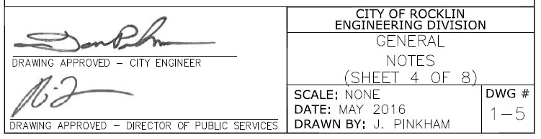

ALL UNSUITABLE AND SURPLUS MATERIAL SHALL BECOME THE PROPERTY OF THE CONTRACTOR AND SHALL BE REMOVED FROM THE SITE UNLESS THE ENGINEER SPECIFIES OTHERWISE.
- UTILITY TRENCHING TO BE COMPLETED WITH FINAL EARTHWORK. THE PROJECT WILL BE TEMPORARILY SUSPENDED PER SEC 8-1.05 FOR ALLOWING PG&E AND WAVE BROADBAND TO INSTALL THEIR RESPECTIVE FACILITIES.

- THE CONTRACTOR SHALL AT ALL TIMES CONFORM TO THE RECOMMENDATIONS FROM THE CITY OF ROCKLIN ON DUST CONTROL, AND ANY REQUIREMENTS OF PLACER COUNTY AIR POLLUTION CONTROL DISTRICT. AREAS SURROUNDING THE WORK SHALL BE KEPT CLEAN AND RETURNED TO ORIGINAL CONDITION UPON COMPLETION OF CONTRACT. GRADING SHALL NOT OCCUR WHEN WIND SPEED EXCEEDS 10 MPH CONTINUOUSLY FOR MORE THAN 1 HOUR.

- CONTRACTOR SHALL APPLY EROSION CONTROL HYDROSEEDING TO ALL GRADED OR DISTURBED SOILS WITHIN THE WORK AREA AFTER COMPLETION OF IMPROVEMENTS OR AS SOON AS PRACTICAL AFTER GRADING TO REDUCE DUST AND EROSION POTENTIAL. STRAW OR HYDROMULCHING SHALL BE COMBINED WITH THE SEEDING ON SLOPES EQUAL TO OR GREATER THAN 10:1 AND PLACED PRIOR TO COMPLETION OF PROJECT IF DEEMED NECESSARY FOR CONTROLLING SOIL EROSION.

- THE CONTRACTOR SHALL DO THE FOLLOWING IF GRADING AND CLEARING IMPROVEMENTS ARE INCOMPLETE BY OCTOBER 1ST:

  - INSTALL EROSION PROTECTION ON SLOPES 10:1 OR STEEPER AND SWALES WITH SLOPES 2% OR GREATER

  - PREVENT SEDIMENT FROM LEAVING THE PROJECT AREA

  - GRADE GUTTER SAG POINTS TO DRAIN. PROVIDE FOR DRAINAGE FROM ENDS OF IMPROVEMENTS

  - PREVENT SEDIMENTATION IN EXISTING STORM DRAIN SYSTEM AND CLEAN PIPES AS PER SPECIFICATION SS62

  - SEAL OFF ALL SANITARY SEWER CONNECTIONS TO EXISTING SYSTEMS

THE CONTRACTOR SHALL MAINTAIN WINTERIZATION FACILITIES AT ALL TIMES UNTIL THE CITY ACCEPTS THE ROAD IMPROVEMENTS

- PRIOR TO GRADING, A RAPTOR SURVEY SHALL BE DONE. NO CONSTRUCTION ACTIVITIES ARE ALLOWED WITHIN .25 MILES OF ANY IDENTIFIED RAPTOR NESTS BETWEEN THE DATES OF FEBRUARY 1ST THRU AUGUST 31ST AS APPROVED BY DIRECTOR.

- APPROX. QUANTITY OF EARTHWORK: CY CUT, CY FILL

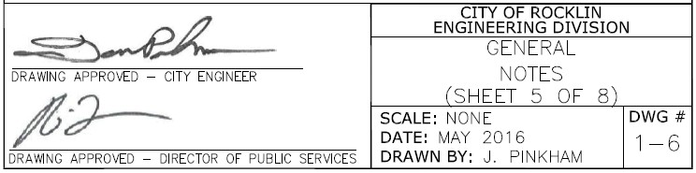

- THOSE ENGAGED IN CONSTRUCTION ACTIVITY SHALL COMPLY WITH THE CITY OF ROCKLIN CONSTRUCTION NOISE COMPATIBILITY GUIDELINES, INCLUDING RESTRICTING CONSTRUCTION NOISE GENERATING ACTIVITIES WITHIN OR NEAR RESIDENTIAL AREAS TO BETWEEN 7:00 AM AND 7:00 PM ON WEEKDAYS AND 8:00 AM AND 7:00 PM ON THE WEEKENDS TO THE SATISFACTION OF THE PUBLIC SERVICES DIRECTOR OR BUILDING OFFICIAL.

STRIPING

- ALL EXISTING PAVEMENT MARKINGS TO BE REMOVED SHALL BE REMOVED BY GRINDING, AND A SURFACE TREATMENT MAY BE REQUIRED BY THE CITY.

- ALL PAVEMENT MARKINGS SHALL BE THERMOPLASTIC AND ARE TO CONFORM TO THE MOST RECENT EDITION OF THE CALTRANS STANDARD SPECIFICATIONS AND PLANS.

CONSTRUCTION STAKING/MONUMENTATION

- NO WORK SHALL COMMENCE UNTIL STAKING IS PROVIDED.

- THE CONTRACTOR IS RESPONSIBLE FOR THE PROTECTION OF ALL MONUMENTS AND OTHER SURVEY MARKERS.

- ALL SURVEY MONUMENTS SHALL BE SET IN ACCORDANCE WITH THE CITY OF ROCKLIN SUBDIVISION ORDINANCE PRIOR TO FINAL INSPECTION AND ACCEPTANCE OF PUBLIC IMPROVEMENTS. MONUMENT BOXES SHALL BE FROM “IRONSIDES” 1B-BODY WITH IL-LID MARKED “MONUMENT” OR APPROVED EQUAL.

LANDSCAPING

- RAIN BIRD® ESP-LX SERIES COMMERCIAL CONTROLLER WITH FLOW SMART MODULE WITH LEARN FLOW UTILITY AND FLOW USAGE TOTALIZER.

- ALL CONTROLLERS SHALL HAVE AN NCC -3G CELLULAR CARTRIDGE WITH EXTERNAL ANTENNA USED FOR DIRECT COMMUNICATION WITH THE IQ CENTRAL COMPUTER.

- NO CO-MINGLING OF ONSITE AND CITY OF ROCKLIN IRRIGATION AND LANDSCAPE

- ALL IRRIGATION AND LANDSCAPE SUBMITTALS SHALL BE SENT TO CITY OF ROCKLIN INSPECTOR 916- 625-5577

- ALL IRRIGATION MAINLINE AND LATERALS SHALL BE SCHEDULE 40 PVC OR GREATER. NO CLASS 200.

- ALL BACKFLOWS SHALL BE A WILKINS 975XL INSTALLED PER PCWA SPEC WITH AN INSULATED PLACER WATER WORKS ENCLOSURE.

- ALL IRRIGATION AND LANDSCAPE SHALL CONFORM TO THE LATEST CALIFORNIA MWELO.

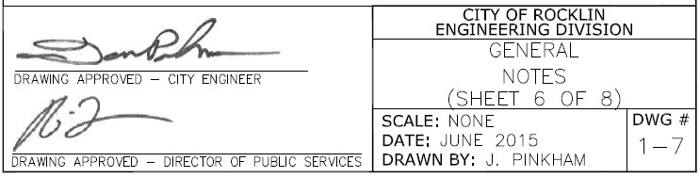

STORM DRAINS

STORM DRAIN REQUIREMENTS SHALL BE PER THE CITY OF ROCKLIN STANDARD SPECIFICATIONS INSTALLED PER MANUFACTURER’S RECOMMENDATIONS. MINIMUM OF 12” DIAMETER PIPE WITHIN THE CITY RIGHT OF WAY AND MINIMUM 8” DIAMETER PIPE ON PRIVATE PROPERTY.
PIPE ALTERNATIVES SHALL BE:

  - CONCRETE PIPE C76 REINFORCED CONCRETE PIPE
  - ASTM-12” IS SMALLEST
  - ASTM-C76 CLASS 5 (UNLESS OTHERWISE SHOWN ON PLANS)
  - HDPE (PER CALTRANS STANDARD, DIVISION VII, MOST RECENT EDITION)

THE CONTRACTOR SHALL MAINTAIN ALL EXISTING DRAINAGE FACILITIES WITHIN THE CONSTRUCTION AREA UNTIL NEW DRAINAGE IMPROVEMENTS ARE IN PLACE AND FUNCTIONING.

EXISTING STORM DRAIN FACILITIES SHALL BE EXPOSED AND INVERT VERIFIED PRIOR TO PLACEMENT OF PIPE. ALL CONSTRUCTION SHALL CONFORM TO MANUFACTURERS SPECIFICATIONS AND TO REQUIREMENTS OF THE CITY OF ROCKLIN STANDARD SPECIFICATIONS.

CONFINED SPACE ENTRY (STORM DRAIN MANHOLES AND TRENCHING):

IT IS THE PROJECT OWNER/DEVELOPER’S RESPONSIBILITY AS HOST EMPLOYER TO HAVE A CONFINED SPACE ENTRY PROGRAM IN COMPLIANCE WITH THE REQUIREMENTS OF SECTIONS 5156-5159 OF TITLE 8, GENERAL INDUSTRIAL SAFETY ORDERS, AND CALIFORNIA CODE OF REGULATIONS. CITY OF ROCKLIN EXISTING MANHOLES ARE “PERMIT REQUIRED” CONFINED SPACES. THE HOST EMPLOYER’S CONTRACTOR MUST STRICTLY CONFORM TO THE CITY OF ROCKLIN PERMIT REQUIRED CONFINED SPACE ENTRY PROGRAM IN ENTERING ANY CITY OF ROCKLIN OWNED MANHOLE. REFER TO GS7-1.06.

A “NO DUMPING” STORM DRAIN MESSAGE SHALL BE PLACED ADJACENT TO ALL DRAIN INLETS IN ACCORDANCE WITH CITY STANDARD DRAWING 4-24.

SEWER

CONTACT SOUTH PLACER MUNICIPAL UTILITY DISTRICT FOR REQUIRED NOTES PERTAINING TO THE SEWER SYSTEM.

WATER

CONTACT PLACER COUNTY WATER AGENCY FOR REQUIRED NOTES PERTAINING TO THE WATER SYSTEM.

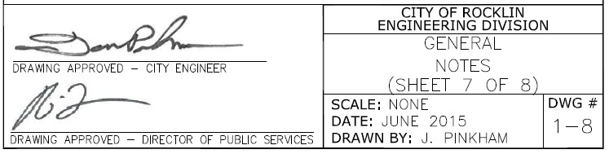

BIOLOGICAL RESOURCES

PRIOR TO GRADING OR CONSTRUCTION ACTIVITIES, THE OPEN SPACE/WETLAND/RIPARIAN AREAS SHALL BE FENCED WITH ORANGE CONSTRUCTION FENCING SUCH THAT THE FENCING SEPARATES THE PROJECT SITE FROM THE OPEN SPACE/WETLAND/RIPARIAN AREAS. THE FENCING SHALL BE INSTALLED TO THE SATISFACTION OF THE CITY ENGINEER AND SHALL REMAIN IN PLACE DURING ALL CONSTRUCTION ACTIVITIES.

CULTURAL RESOURCES

IF EVIDENCE OF ARCHEOLOGICAL OR PALEONTOLOGICAL SITE IS UNCOVERED DURING GRADING OR OTHER CONSTRUCTION ACTIVITIES, WORK SHALL BE HALTED WITHIN 100 FT OF THE FIND AND THE CITY OF ROCKLIN ENVIRONMENTAL SERVICES DIVISION SHALL BE IMMEDIATELY NOTIFIED. A QUALIFIED ARCHAEOLOGIST OR PALEONTOLOGIST SHALL BE RETAINED AT THE EXPENSE OF THE DEVELOPER/CITY TO CONDUCT AN ON-SITE EVALUATION AND PROVIDE RECOMMENDATIONS FOR REMOVAL AND/OR PRESERVATION. WORK ON THE SITE SHALL NOT RESUME UNTIL THE ARCHAEOLOGIST OR PALEONTOLOGIST HAS HAD REASONABLE TIME TO CONDUCT AN EXAMINATION AND IMPLEMENT MITIGATION MEASURES DEEMED APPROPRIATE AND NECESSARY BY THE ENVIRONMENTAL SERVICES DIVISION TO REDUCE IMPACTS TO A LESS THAN SIGNIFICANT LEVEL.

EVIDENCE OF HUMAN BURIAL OR SCATTERED HUMAN REMAINS RELATED TO PRE-HISTORIC OCCUPATION OF THE AREA COULD BE INADVERTENTLY ENCOUNTERED ANYWHERE WITHIN THE PROJECT AREA DURING CONSTRUCTION ACTIVITY OR OTHER ACTIONS INVOLVING DISTURBANCE TO THE GROUND SURFACE AND SUBSURFACE COMPONENTS. IN THE EVENT OF SUCH AN INADVERTENT DISCOVERY, WORK SHALL BE HALTED WITHIN 100 FT OF THE FIND AND THE CITY OF ROCKLIN ENVIRONMENTAL SERVICES DIVISION AND THE COUNTY CORONER SHALL BE IMMEDIATELY NOTIFIED AND CONSULTED, PER STATE LAW.

AIR QUALITY

PRIOR TO ANY GRADING OR CONSTRUCTION ACTIVITY, A DUST CONTROL PLAN SHALL BE SUBMITTED FOR APPROVAL BY THE CITY ENGINEER AND THE PLACER COUNTY AIR POLLUTION CONTROL DISTRICT. THE DUST CONTROL PLAN SHALL SPECIFY MEASURES TO REDUCE DUST POLLUTION DURING ALL PHASES OF CONSTRUCTION.

